AI BASED DIABETES PREDICTION SYSTEM

* Diabetes is a chronic medical condition that affects how your body processes glucose (sugar), which is the primary source of energy for your cells.
* When you have diabetes, your body either doesn't produce enough insulin (a hormone that regulates blood sugar) or can't effectively use the insulin it produces. This leads to elevated blood sugar levels, which can have various health implications.

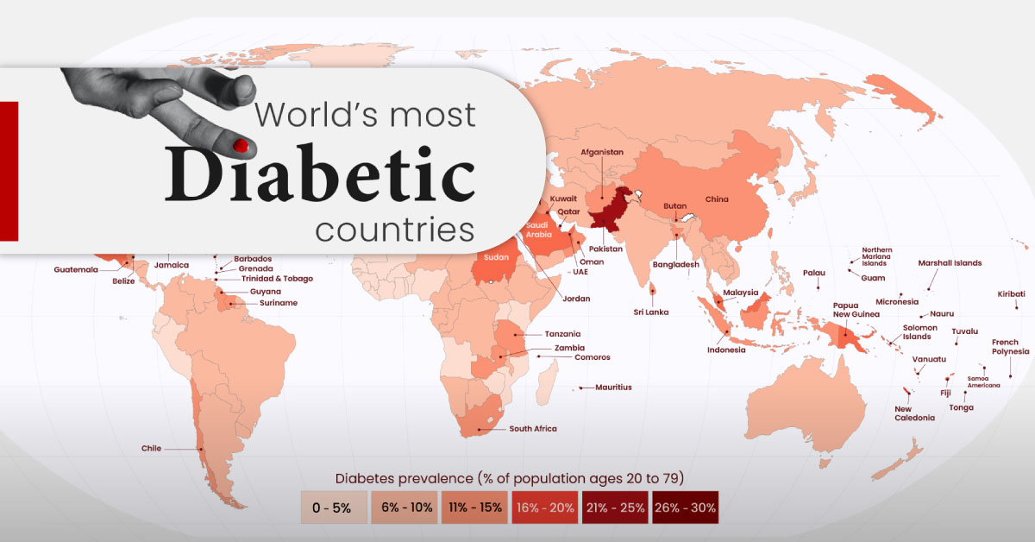

**TYPES OF DIABETES**

* + - * **TYPE 1**
      * **TYPE 2**
      * **GESTATIONAL DIABETES**

ABSTRACT

* Our project aims to develop an advanced AI-powered diabetes prediction system that leverages state-of the-art machine learning algorithms to analyze comprehensive medical data. The primary objective is to accurately predict the likelihood of an individual developing diabetes, enabling early risk assessment.
* Moreover, the system strives to offer personalized preventive measures, empowering individuals to take proactive actions to manage their health effectively. By combining the capabilities of artificial intelligence and extensive medical data analysis, this system addresses the critical need for early detection and proactive health management in the context of diabetes. It represents a significant step towards reducing the burden of this chronic condition on individuals and healthcare systems, ultimately improving the overall quality of life for those at risk.

TECHNOLOGY USED

DATA SET:

Kaggle offers a multiple diabetes related datasets that you can explore including patient information,clinical measurements and outcome labels.

DATA PREPROCESSING:

Python is a popular language for AI and libraries like Numpy,pandas used for data cleaning,transformation and manipulation.

MODEL SELECTION AND TRAINING:

Scikit-learn provides a wide range of tools and algorithms for various machine learning and data analysis task.

EVALUATION:

Scikit-learn offers metrics and tools for model evaluation and cross validation.

ITERATIVE IMPROVEMENT:

Optuna is a hyperparameter optimization that can help fine tune for machine learning models.

OTHER AI TOOLS:

IBM Watson Health is offering solutions for healthcare and is used for analysing the medical data records.